Query Behavior Specification

Query Behavior Specification

1. Introduction and Problem Statement
The current filtering system makes it hard for users to refine and analyze data. Filters are spread across different areas, don’t support exclusion (IS NOT), and lack AND logic within filters + OR logic between filters. making complex searches difficult. This update will improve filter flexibility, simplify the UI, and make filtering more intuitive and efficient.

2. Filters Components & Terminology

1. Filter Menu Figma
The Filter Menu is where users select a filter to apply.
Choosing a filter opens the corresponding Query Modal for configuration.
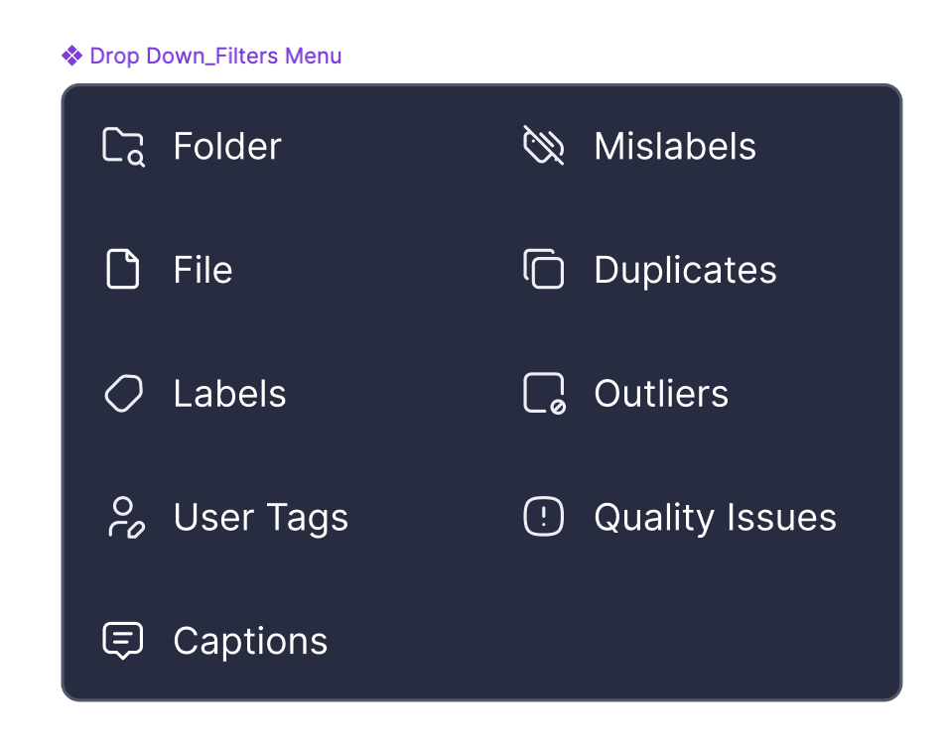

Filters Available from the Menu:
- Labels
- User Tags
- Captions
- Objects
- Duplicates
- Mislabels
- Outliers
- Quality Issues (Dark, Bright, Blurry)
- File: image/video
- Folder
*Objects = Labels? Terminology TBD with Amir - not finalized yet.
Amit Vizel

Dynamic Filter Menu Behavior:
The Filter Menu should be dynamic, adjusting based on the dataset and the current view:
- AND Logic: Filters are available based on what exists in the current view.
- OR Logic: Filters are available based on the entire dataset.
- Exclude Logic: Filters apply only to items currently in the view.

2. Query Modal
The Query Modal is where users define a filter's logic, parameters, and conditions before applying it to the Query Panel.

Query Modal Functionality:
- Selecting a filter from the Filter Menu opens its Query Modal.
- Each filter type has specific configuration options based on its logic and input type.

Inside the Query Modal:
The Query Modal consists of two key components:
- Filter Condition Selector (Defines logic like IS, IS NOT, CONTAINS)
- Value/Input Component (Defines how users enter values, e.g., dropdowns, sliders)

Applying Filters: Figma

- Instantly Applied Filters: Changes take effect immediately (sliders)
- Explicit Confirmation Filters: Users must click "Apply" to save changes (multi-selection lists).
- Clicking "Cancel" or clicking outside the modal discards changes.

3. Query Tab
A Query Tab represents an applied filter inside the Query Panel. Each Query Tab corresponds to one configured filter with a single condition.
- Users can edit, remove, or reorder Query Tabs within the panel.
- Query Tabs are grouped into AND, OR, or Exclude rows based on logic.
- Each Query Tab contains only one condition (IS, IS NOT, CONTAINS…)
- If a newly applied filter matches an existing Query Tab (same filter type, condition, and values), it will be grouped within that tab instead of creating a new one. - We will add a blinking state to the query tab component to indicate that a filter was added to a specific tab.
- If a user applies the same filter type but with a different value, it will create a new Query Tab rather than merging with an existing one.
- Query Tabs will display a short text row summarizing the applied condition and parameters. If the text is too long, users can view the full content via a tooltip- following the same behavior as captions on images today.
- Need to define the structure for the summarized row.

4. Query Panel (Filters Management)
The Query Panel is where users view, edit, and organize filters into three distinct rows, each following different logic rules.

Query Panel Structure - Filter Logic (AND / OR / Exclude) Specification:
- AND (First Row - Default Filters):
All conditions must be met (narrows results)
- Filters in this row follow AND logic, meaning all conditions must be met.
- Order does not matter, except for the first filter/search, which may influence results (as a starting point).
- OR (Second Row - Advanced Filters):
Any condition can be met (expands results)
- Filters in this row follow OR logic, meaning results can match any of the conditions.
- Exclude (Third Row - Special Actions & Exclusions):
Removes results matching the condition.
Used for special exclusion-based actions, such as:
- Visual Similarity
- Hide Duplicates
- Sampling - Select uniques
- Specific Anchors (such as selected items/clusters)

How Filter Logic is Determined
The logic (AND / OR / Exclude) is automatically assigned based on how the user adds the filter.
User Action | Logic Applied | Row Placement
Search Via ‘Search bar’ | AND | First Row (AND)
Clicking ‘Add Filter’ (First filter)   | AND | First Row (AND)
Clicking ‘Advanced Filters’  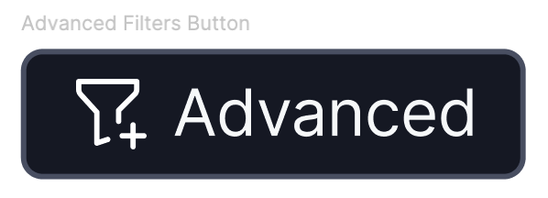 | OR or Exclude  (User selects) | Second (OR) or Third row (exclude)
Clicking ‘Add More’ in a specific Row | Matches row logic | Same Row (AND/OR/Exclude)
Performing a special action (e.g. Hide duplicates, Visual similarity action, Select Uniques) | Exclude | Third Row (Exclude)

Key Considerations:
- Filters automatically go to the correct row based on the action taken.
- Users can only add AND filters first, OR & Exclude require advanced selection.
- Some filters may allow mixed logic inside their Query Modal (e.g. NOT,One Of) -
#Regular ‘NOT’ logic is handled inside the Query Modal, not in the Exclude row.

Interaction inside the query panel:
- Editing Filters:
- Clicking on an applied filter - the ‘query tab’ opens its Query Modal, allowing adjustments.

- Reordering Filters: low priority
- AND row filters can be reordered but always follow AND logic.
- OR and Exclude filters remain in their respective rows.

- Removing Filters:
- Users can delete a filter, which removes it from the query structure.

- Expanding/Collapsing the Query Panel:
- Users can toggle visibility to manage applied filters more easily.

Future Enhancement: Query Panel Text Mode
In the future, we may introduce a toggle option that allows users to switch between:
1. Visual Mode: Query Tabs for structured filtering.
2. Text Mode: A written query format for advanced users (similar to Jira’s JQL).
Key Considerations:
- Users can edit queries manually without losing the ability to switch back to visual mode.
- This will require a clear and structured query syntax (VQL) to support bidirectional conversion.
- Not in scope for the initial implementation, but could provide greater flexibility for technical users.

3. Query Language (VQL) Requirements
To enable structured and flexible filtering, we are introducing Visual Layer Query Language (VQL). VQL ensures that queries are:

- Human-readable & machine-parsable: for ease of use.
- Composable & scalable: supporting complex logical conditions (AND, OR, EXCLUDE)
- Compatible with API execution: allowing external integrations.
VQL Structure Example:
{
"entity": "objects",
"filters": {
"AND": [
{ "type": "labels", "operator": "IS_ONE_OF", "values": ["cat", "dog"] },
{ "type": "duplicates", "operator": "IS", "threshold": 80 }
],
"EXCLUDE": [
{ "type": "visual_similarity", "operator": "IS", "anchor": "image_123" }
]
}
}

# Each filter in the UI maps to a structured query in VQL.
# Filters are grouped by logic (AND, OR, EXCLUDE) to maintain consistency.

4. Updated API Integration Section
The system must support query execution via API, ensuring consistency across environments.

API Considerations:
- Query Execution: API must support direct query execution.
- Format: The team will evaluate the best approach for handling queries, considering:
  - GET: Suitable for simple queries but limited by URL length.
  - POST: Allows complex queries in the request body, avoiding length constraints.
  - Alternative methods: Other architectures may be explored based on scalability and performance.
- Scalability: The API should efficiently handle large datasets and complex queries.
Example API Request (for discussion, subject to decision):
Example using POST:

POST /query
{
"entity": "images",
"filters": {
"AND": [
{ "type": "user_tags", "operator": "IS_NOT_ONE_OF", "values": ["rejected", "needs_review"] },
{ "type": "quality_issues", "operator": "IS", "values": ["blurry", "dark"] }
],
"EXCLUDE": [
{ "type": "visual_similarity", "operator": "SIMILAR_TO", "anchor": "image_123" }
]
}
}

# Final API structure (GET vs. POST) is yet to be determined and will be decided based on feasibility and performance research.
# The API should function consistently across all environments.

5. Prefilled Defaults & Memory Behavior

Prefilled Defaults
To enhance efficiency and minimize manual input, each Query Modal will open with a default selection based on the most common user behavior.
Each Query Modal will have predefined default values according to its filter type. Defaults are designed to:
  - Reduce repetitive manual input for frequent actions.
  - Ensure consistency across different filter types.
  - Provide a logical starting point for filtering.

Each filter will have its own default behavior, including:
- Default condition (IS, IS ONE OF…)
- Pre-filled values (if applicable)
Remembering User Inputs:
To improve usability, the system will retain user-defined values within the same session:
- If a user reopens a Query Modal during an active session, the last used values will be prefilled.
- If a new session starts or the query is reset, filters revert to their default settings.

6. Filter Logic & Behavior

A. Filter Condition Selector (Logical Operations per Filter Type)
Each Query Modal includes a Filter Condition Selector, allowing users to define the logic applied to a filter.

1. Supported Filter Conditions: Figma
Defines the logical operation applied to the filter. Supported conditions vary by filter type:

Binary Conditions (Single Selection)
- IS: Includes only results that match the selected value.
- IS NOT: Excludes results that match the selected value.

Multi-Selection Conditions
- IS ONE OF: Includes results that match at least one of the selected values (OR logic).
- IS NOT ONE OF: Excludes results that match any of the selected values.

Text-Based Conditions (Search & Name Filtering)
- CONTAINS: Includes results where the field contains the input text.
- DOES NOT CONTAIN: Excludes results where the field contains the input text.
- STARTS WITH: Includes results where the field begins with the input text.
- ENDS WITH: Includes results where the field ends with the input text.
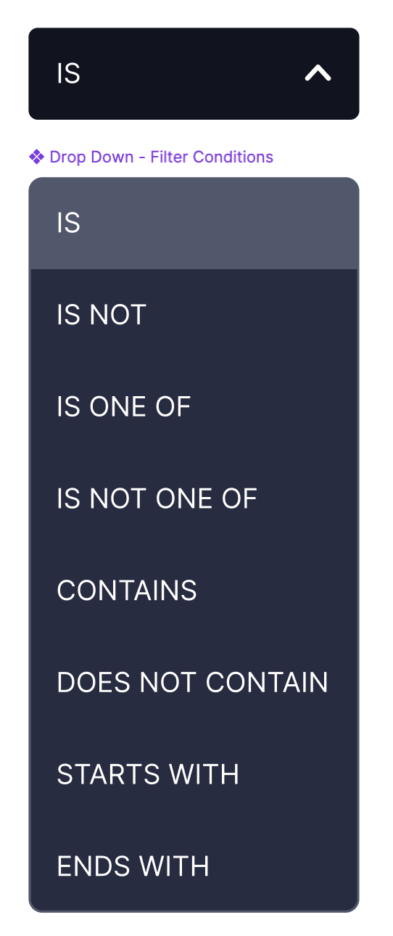

Similarity & Exclusion Logic (Special Cases)
- SIMILAR TO: Includes results visually similar to a selected anchor.
- NOT SIMILAR TO: Excludes results visually similar to a selected anchor (moves query to Exclude row)

2. Value/Input Component
Each Query Modal presents a relevant input type based on the selected filter:
- List - Single Selection: Dropdown or searchable list where users select one value.Figma
- List - Multi-Selection: Checkbox-based list where users select multiple values.Figma
- Text + Search Input: Free-text field for search or filter input Figma
- Counter (Numeric Input): Increment/decrement buttons for numeric values
- Level Threshold (Single Slider): Slider to adjust a single threshold value
- Range Threshold (Dual Slider): Slider with two handles for setting a range
- Relevance Score Selection: redefined categories like Low, Medium, High

Behavior for Statistics in Multi-Selection Lists:

- IS / IS NOT (AND Logic):
Statistics update dynamically to show only items matching all selected conditions. Items with 0 results will be hidden.
- IS ONE OF / IS NOT ONE OF (OR Logic):
Statistics remain unchanged, showing total counts for each option.

B. Filters requirements

1. Text Search
Will be translated into a query within the Query Modal.

Phase 1:
- Users can add only one search query at a time (no multiple semantic searches).
- The search will remain visible in the top search bar for reference and an editable relevance score.

Future Plan:
Allow advanced query logic to combine multiple semantic searches.
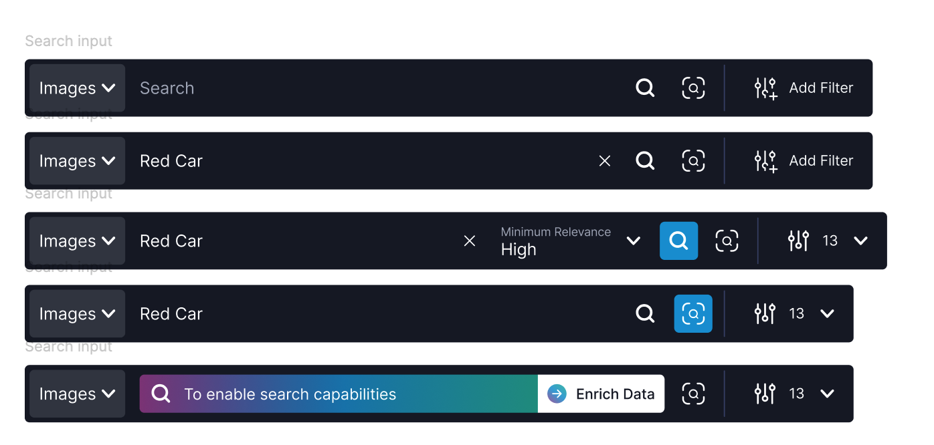

2. Labels

Logic Conditions: IS/ IS NOT/ IS ONE OF
Prefilled Condition: IS ONE OF
Behavior:

Supports multi-selection.
- "IS" uses AND logic within the modal (must match all selected labels).
- Requires clicking "Apply" to confirm changes.

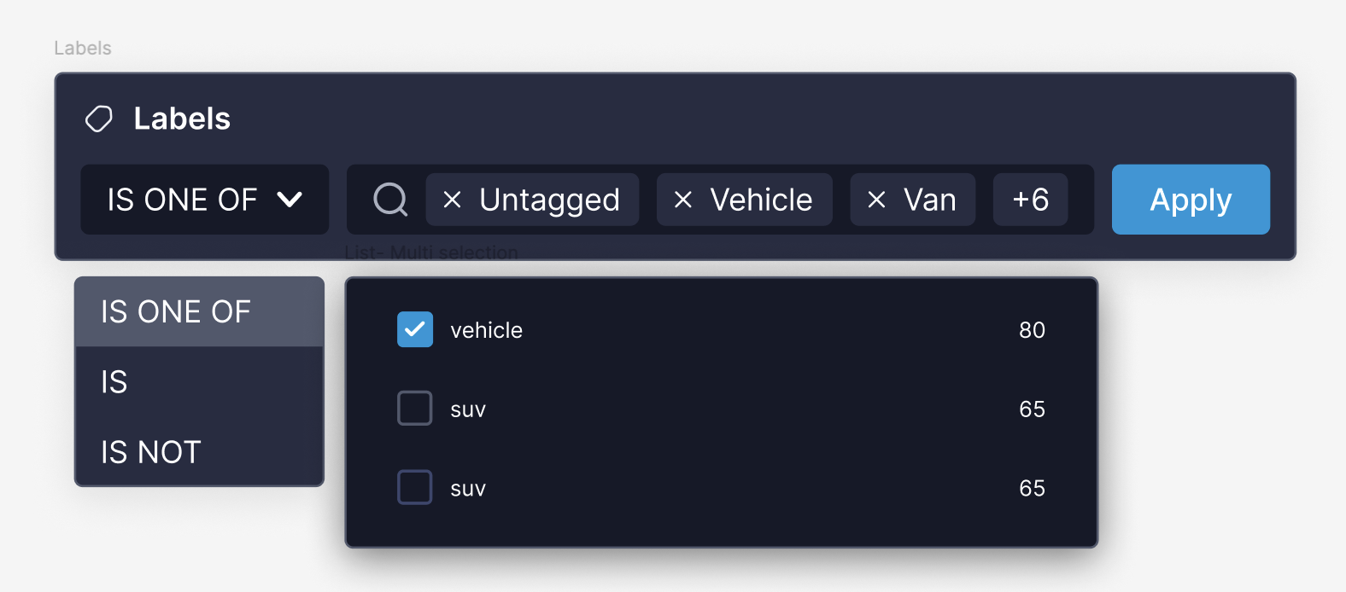
Update:

Labels will be with an additional operator: ‘Source’ for the distinction between user labels/model labels.

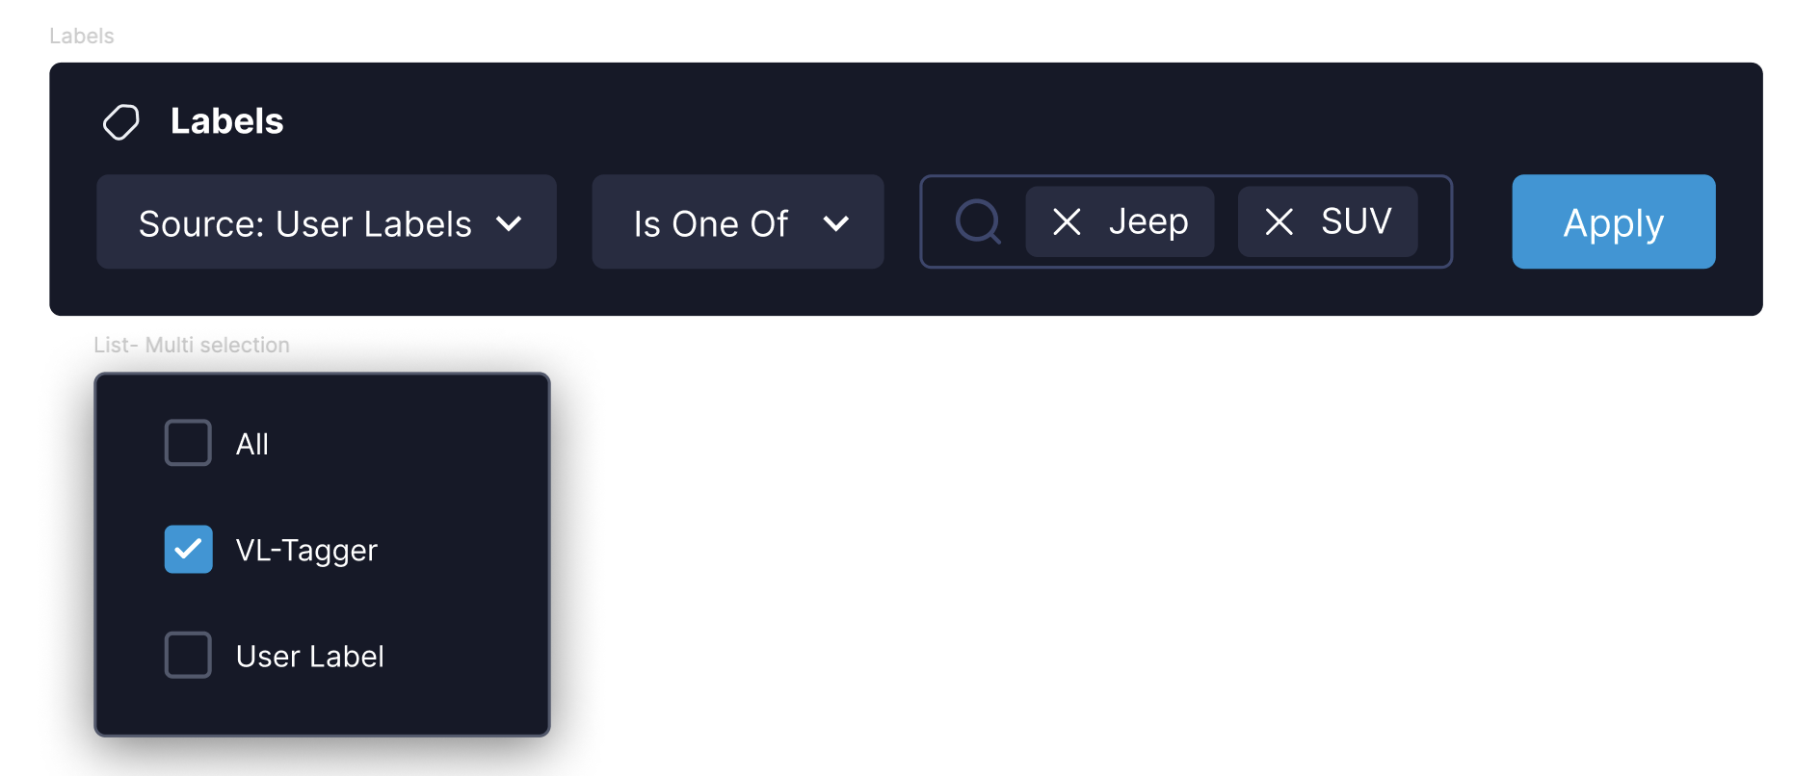
3. User Tags
Logic Conditions: IS/ IS NOT/ IS ONE OF
Prefilled Condition: IS ONE OF
Behavior:
- Supports multi-selection.
- "IS" uses AND logic within the modal (must match all selected labels).
- Requires clicking "Apply" to confirm changes.
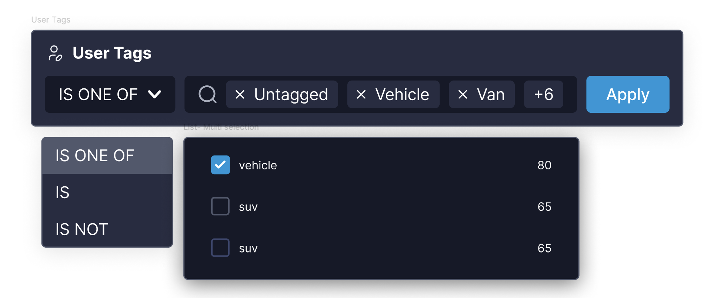

4. Object Labels
Logic Conditions: IS/ IS NOT/ IS ONE OF
Prefilled Condition: IS ONE OF
Behavior:
- Supports multi-selection.
- "IS" uses AND logic within the modal (must match all selected labels).
- Requires clicking "Apply" to confirm changes.
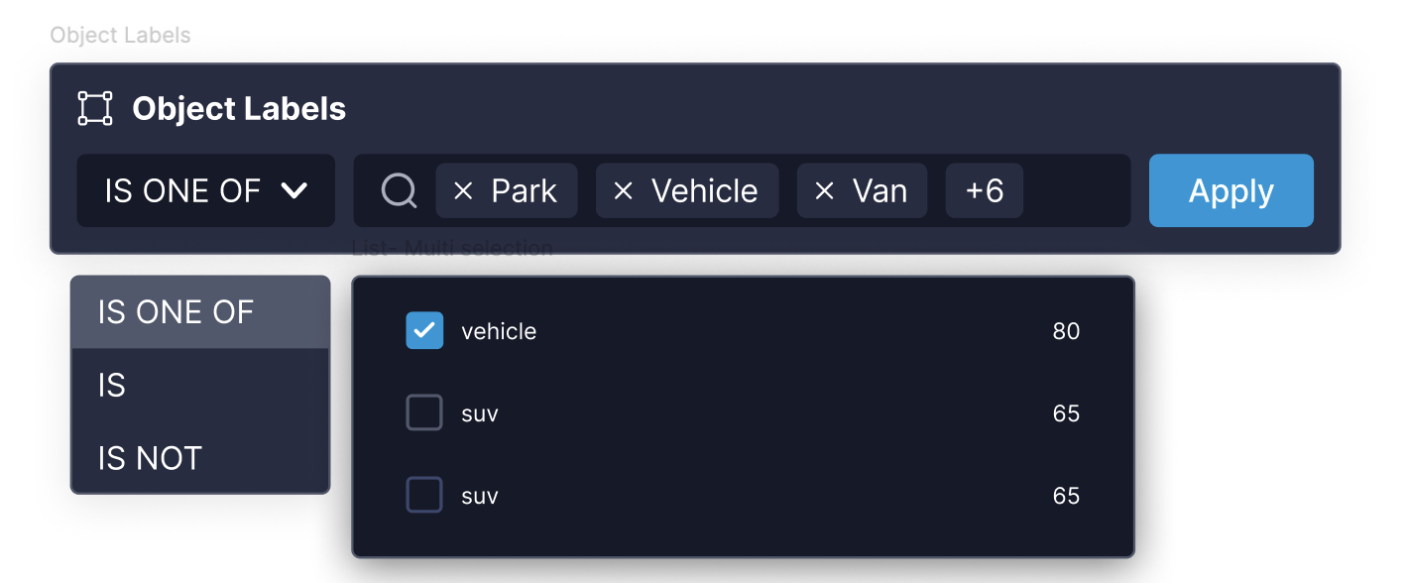

5. Captions
V0:
Logic: Full text Search
Behavior:
- Free-text search inside the field.
- Requires clicking "Apply/Enter” to see the results.
- Unlike other filters the modal should stay open after performing search.
- Users can add only one search query at a time (no multiple captions searches)-?
- prompt.
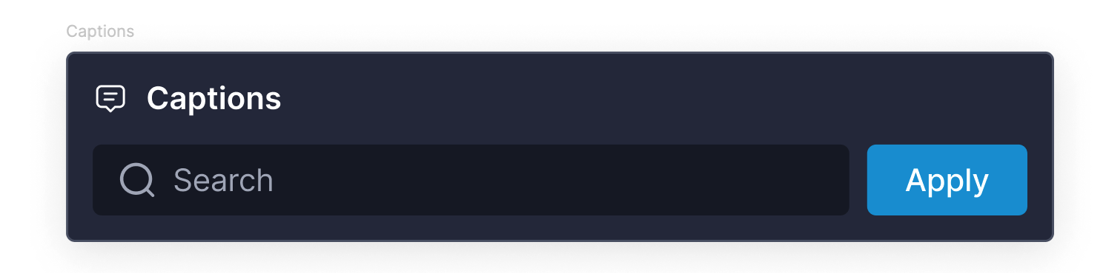
Logic Conditions: CONTAINS / DOES NOT CONTAIN
Prefilled Condition: CONTAINS
Behavior:
- Free-text search inside the field.
- Applies instantly (no "Apply" button).

6. Duplicates
Prefilled Value: 1 (Highest similarity level)
Behavior:
- Similarity Level Slider: Adjusts the threshold for detecting duplicates.
- Duplicate Count: Displays the number of matching duplicates for the selected level.
#The view functionality and filter functionality for duplicates will be separated into two distinct flows:

- Filtering for Duplicates -Users can apply the duplicates filter and adjust the similarity level slider. This applies instantly but does not modify the Duplicates cluster's view.
- Navigating to the Duplicates Clusters View - To focus on duplicates, users will need to navigate through the right pane to access the dedicated duplicates clusters view - Prototype
**For V0, we will still display duplicate clusters when the user applies the filter - the AND logic aligns with this behavior.
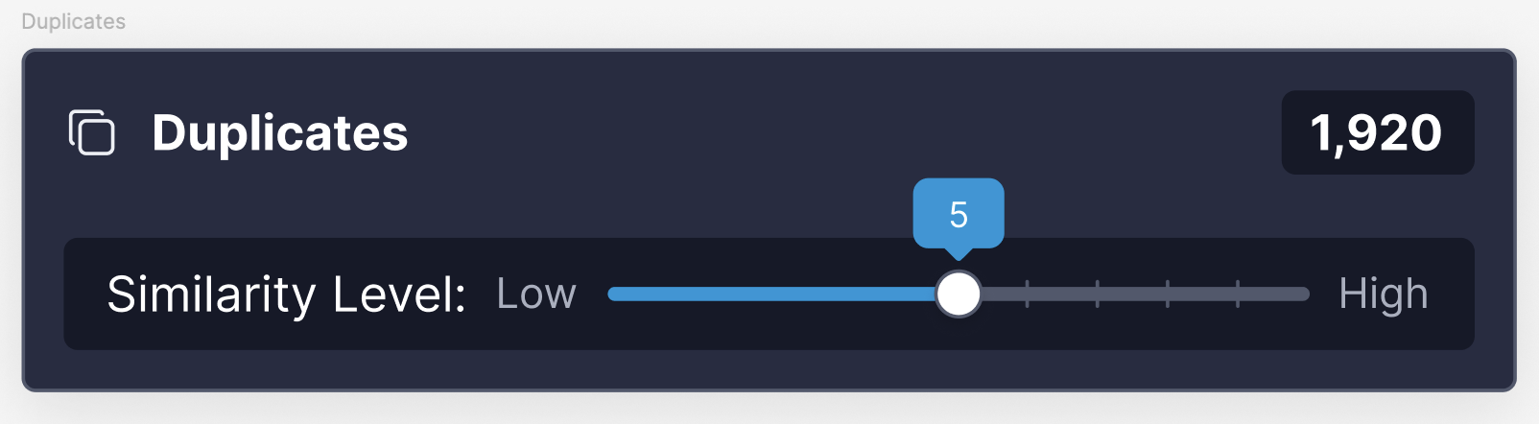

7. Mislabels
Logic Conditions: IS/ IS NOT
Prefilled Condition: IS
Prefilled Value: Confidence Range 0.5-1
Behavior:
- User adjusts the confidence range slider: Sets the confidence threshold (10% - 30%).
- Filter applies instantly: Updates results in real time without needing an "Apply" button.

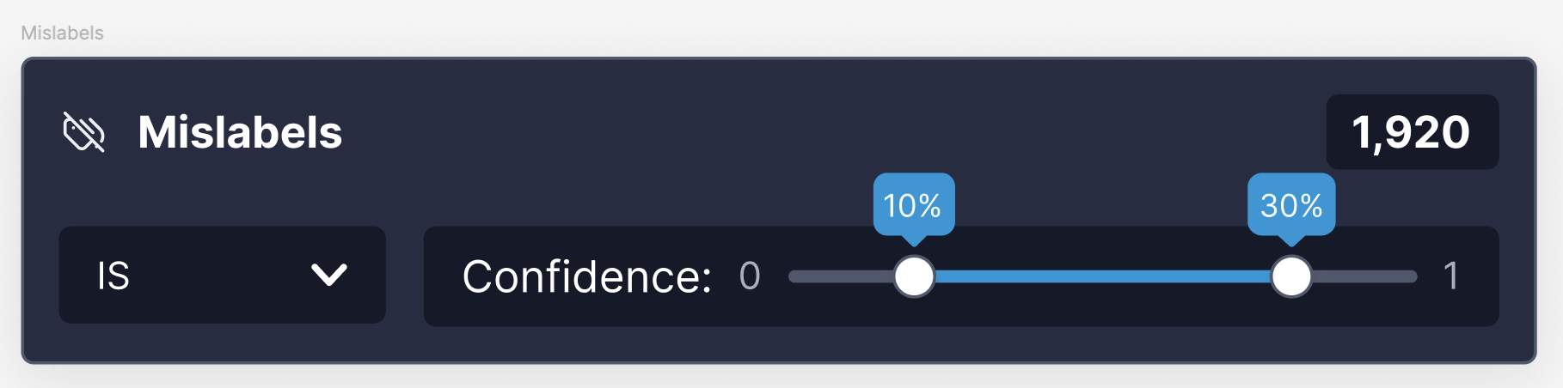

8. Outliers
Logic Conditions: IS/ IS NOT
Prefilled Condition: IS
Behavior:
- Applies instantly: Requires clicking "Apply" to confirm changes.
- Outliers Count: Displays the number of detected outliers.
V0:
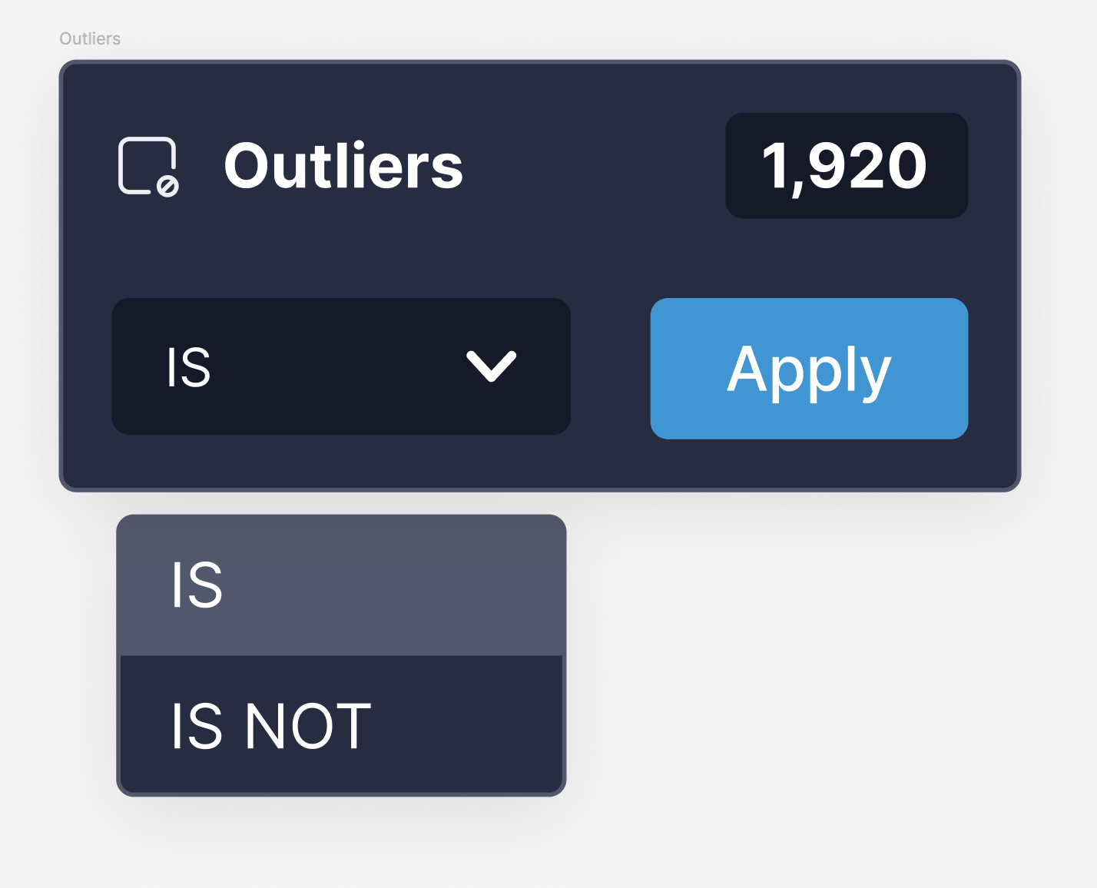
Op 2:
#Adding a Threshold for Outliers - Prioritization Discussion
- We want to introduce a threshold for outliers, allowing users to refine results based on a confidence level.
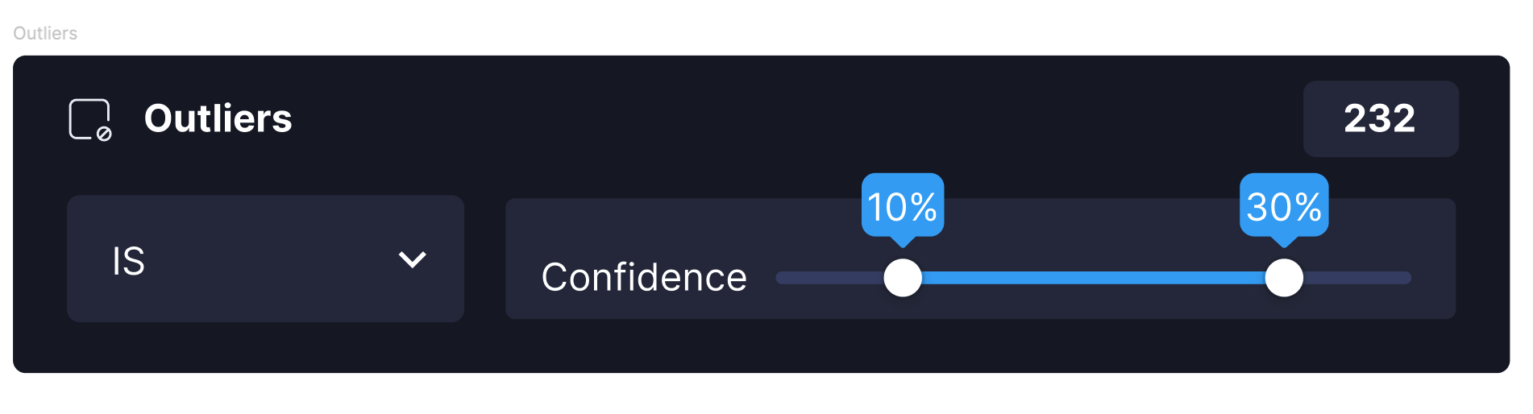
Should we prioritize this now, or add it as part of a future update?

9. Quality Issues: (Dark, Bright, Blurry)
Logic Conditions: IS/ IS NOT
Prefilled Condition: IS
Behavior:
- Update: Quality Issues (Dark, Bright, Blurry) now grouped under a single image quality category
Threshold Filters
- Display the existing confidence value threshold under filters for Dark/Bright/Blurry/Outliers.
- Users can fine-tune the threshold directly from the UI.
- Items below the threshold will not be created (pre-filtered).
- Requires confirmation from Algo to ensure proper implementation.
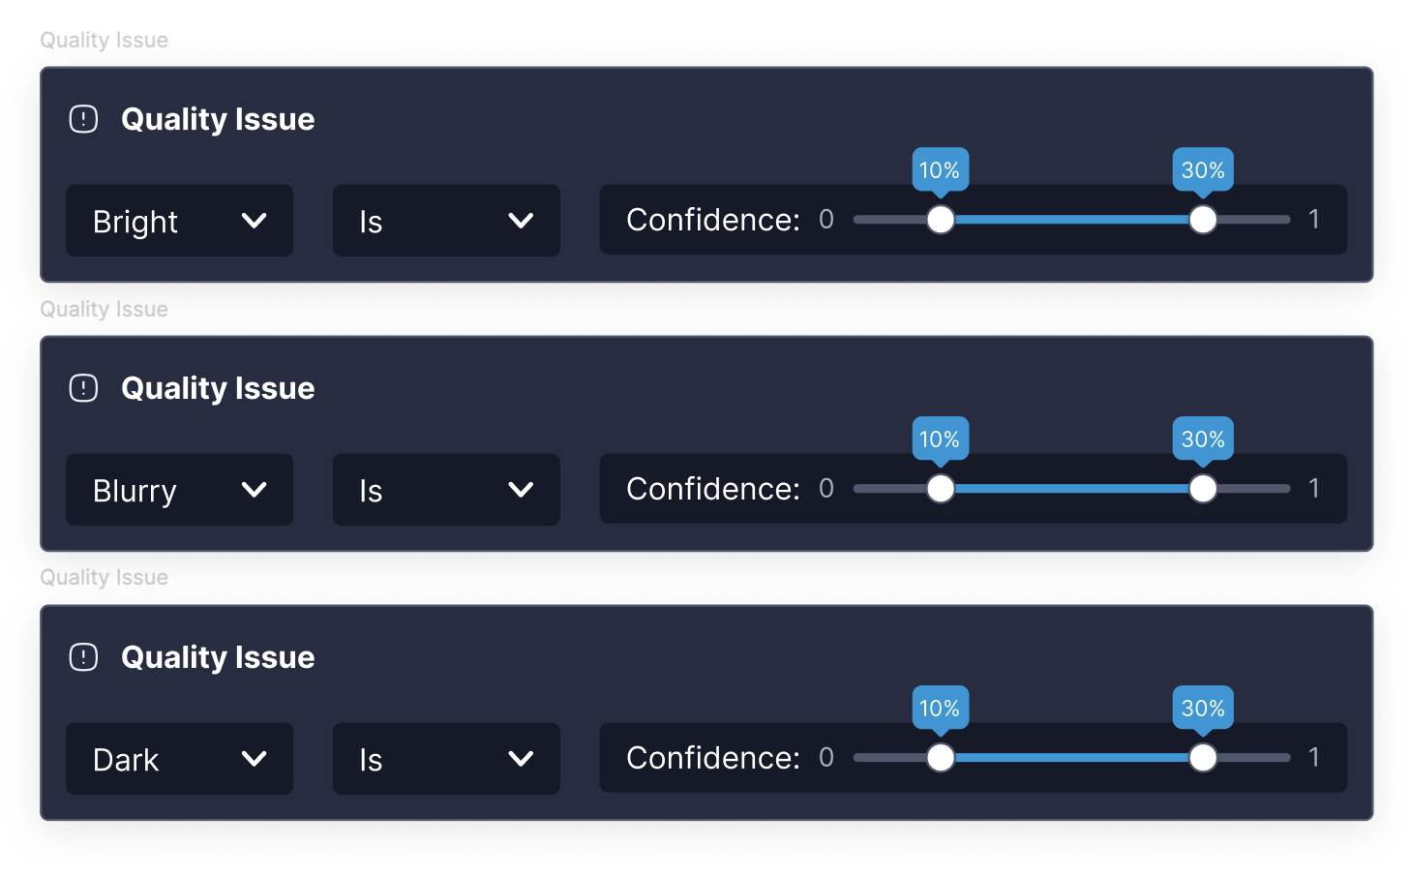

10. File:
Logic Conditions: IS ONE OF/ STARTS WITH / ENDS WITH/ CONTAINS
Prefilled Condition: IS ONE OF
Behavior:
- Selection Type:
Users can choose between Video or Image as the file type.
For V0, the Video/Image selection won't be available - the logic conditions will display both together.
- Filtering Logic:
IS ONE OF:
Allows multi-selection to filter frames from multiple videos with flexible text search.
STARTS WITH / ENDS WITH / CONTAINS:
Enables text-based search for matching video names.
-Text input- requires ‘apply’ button
-Search - multi selection list - apply immediately
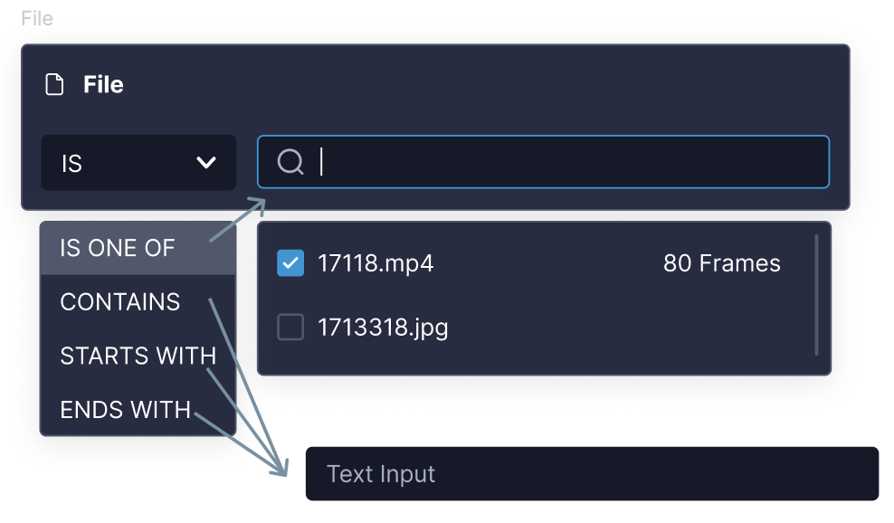

11. Folder
Logic Conditions: IS ONE OF/ STARTS WITH/ ENDS WITH/ CONTAINS
Prefilled Condition: IS ONE OF
-Text input- requires ‘apply’ button
-Search - multi selection list - apply immediately
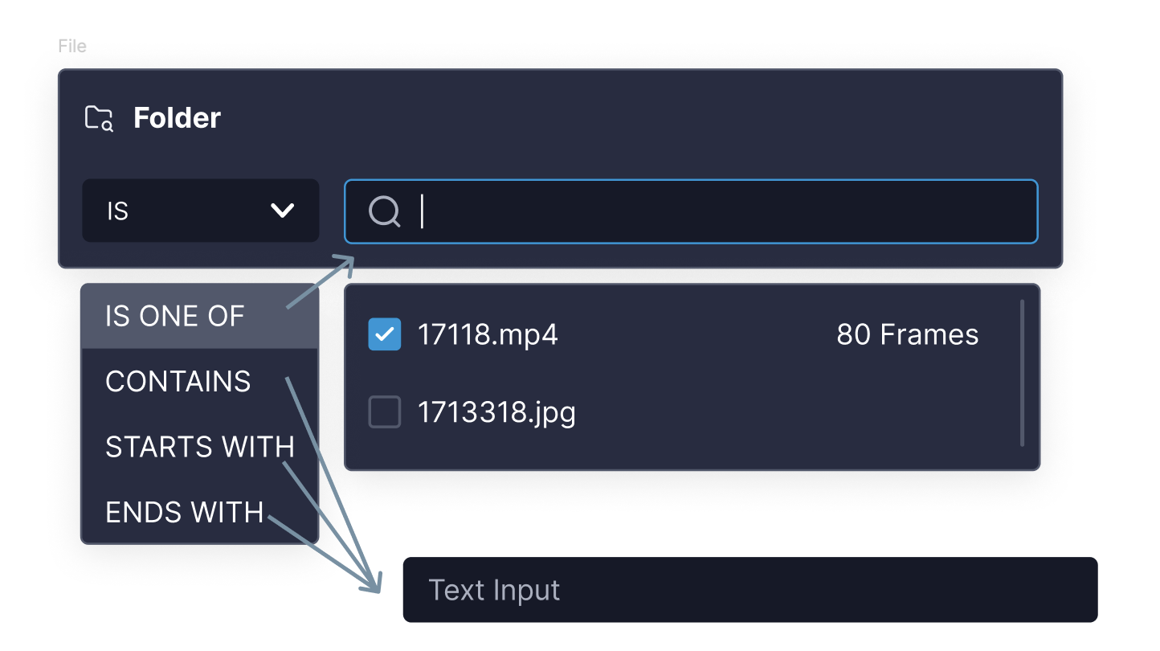

12. Select Uniques
Functionality remains the same:
The filter will display the number of unique items selected based on the slider value.
Placement: This filter will be added to the Exclude row, ensuring that the selected uniques are excluded from the results.
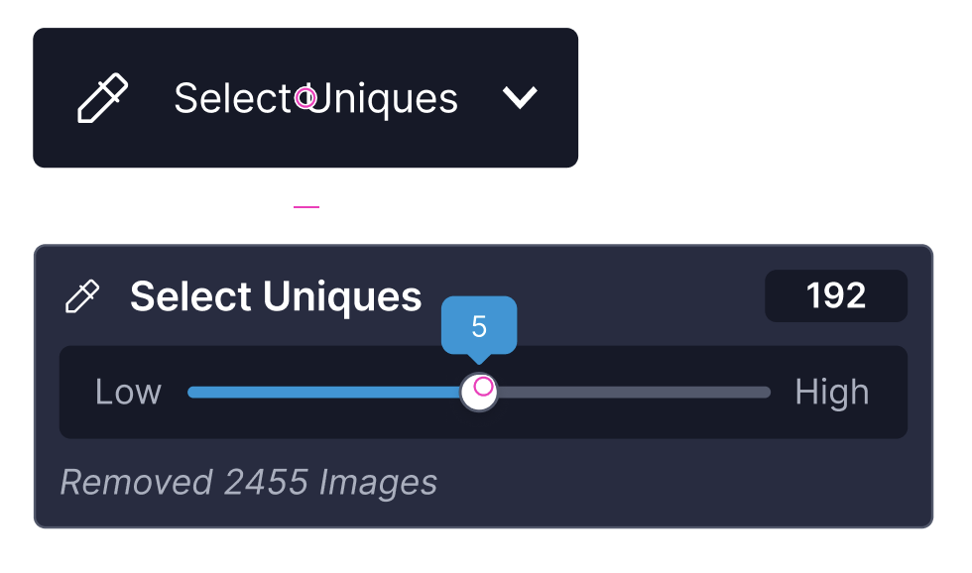
Navigation & Behavior
- Access Point: The user will trigger this action from an independent button located next to the search bar (not from the filters menu).
- Query Panel Display: After applying, this filter will still appear in the Query Panel under the Exclude row.
Open Question:
#After applying the filter, should we keep the button visible or remove it once the filter appears in the Query Panel?

13. Visual Similarity
The existing Find Similar/visual search functionality will be translated into this Query Modal to provide a structured filtering experience.
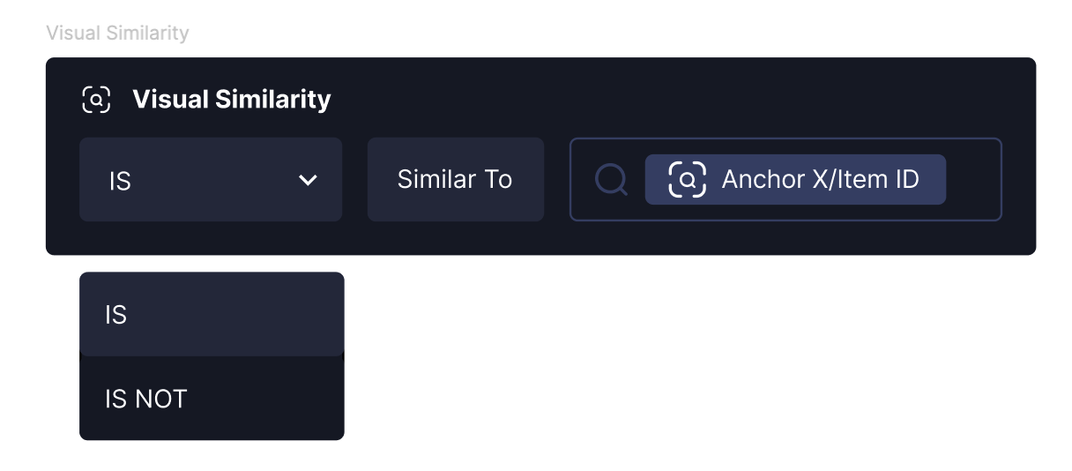

Logic Conditions:
IS: Shows items similar to the selected anchor (multiple/single Item ID).
IS NOT: Moves the query tab to the Exclude row, ensuring that items similar to the selected anchor are removed from the results.
Behavior:
- The user selects an anchor (One image/Cluster) to find visually similar items.
- Applies instantly- no "Apply" button needed.
- If ‘IS NOT’ is selected, it is placed in the Exclude row, filtering out similar items without impacting other AND/OR conditions.
#New Expand Capability for Visual Similarity
We want to allow users to move the Visual Similarity query tab to the OR row (if it exists), enabling a new way to expand results based on visual similarity.

What This Means:
- If in the OR row: Expands results to include items similar to multiple anchors.
- If in the Exclude row: Removes items similar to the selected anchor(s).
- Drag & Drop Support: Users can move the query tab between rows dynamically.
*There will be two additional flows for adding the Visual Similarity query to the OR or Exclude row, beyond drag-and-drop. This functionality will be fully defined in a separate spec.

14. Cluster Filtering & Navigation
Current Behavior:
- Today, when a user enters a cluster, it is added as a filter (Cluster ID).
- This means filtering by cluster happens automatically upon navigation.

Planned Query Modal Updates:
- The new Query Modal will function similarly to this one.
- It will offer more capabilities related to specific items/clusters, giving users more control over filtering.
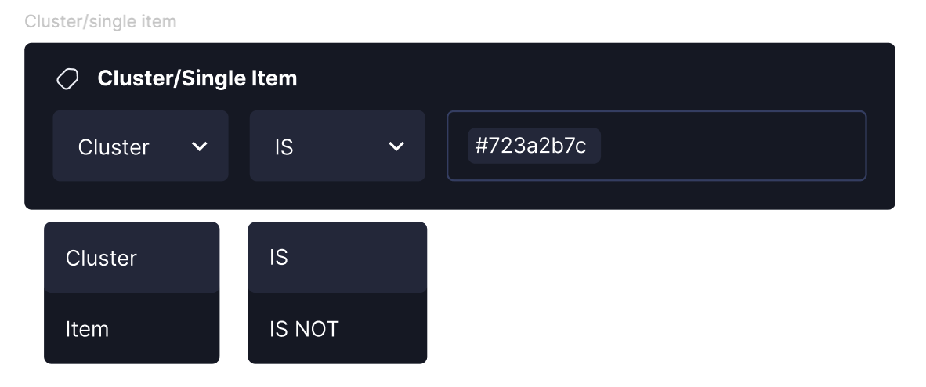

Key Direction: Separation of Navigation & Filtering
- We want to separate "navigating into a cluster" from "filtering a cluster".
- Filtering should be an intentional action rather than an automatic result of navigation.
- The exact implementation is not finalized yet, but this is the general direction.

7. Entities & Explore Flow - Objects & Images
- Entities (Objects & Images) are the first step in the Explore flow, defining the starting point.
- Not part of the Query Panel- users select an entity before applying any filters.
- Objects and Images remain separate entities, each with its own Explore flow.
- Users can switch between entities while preserving their queries (applied filters).
- With Find Similar becoming a query-based behavior (as defined in this spec):
  - Users will be able to switch entities (Objects / Images) even with an active visual search.
  - Unlike today, where Find Similar blocks entity switching, this change allows for a more flexible exploration experience.

8. User Interaction Flows- ​​prototype
This section outlines the step-by-step user experience when interacting with filters, from selection to management.

Adding a Filter
- User clicks "Add Filter" → Opens the Filter Menu.
- User selects a filter → Opens the corresponding Query Modal.
- User configures the filter → Defines logic (e.g., IS, IS NOT, CONTAINS) and selects values.
- User applies the filter → It appears as a Query Tab inside the Query Panel.
- Filters are placed into AND, OR, or Exclude rows based on logic.

Managing Applied Filters
- Edit: Clicking a Query Tab reopens the Query Modal for adjustments.
- Remove: Users can delete a Query Tab, removing the filter.
- Reorder: Users can rearrange AND & OR filters, but Exclude filters stay in place.
- Expand/Collapse: The Query Panel can be toggled for better visibility.

Navigating Between Entities (Objects & Images)
- Users can switch between entities (Objects / Images) while preserving applied filters.
- New Behavior: When Visual Similarity (Find Similar) is applied, entity switching will still be possible- unlike today, where it blocks switching.

9. Implementation Plan & Roadmap
The rollout will be phased to allow FE & BE teams to work in parallel while refining API & query language implementation

Phase 1: Basic UI Implementation
- FE: Build standalone Query Modals (without backend connection).
- BE: Define query language (VQL) & API structure.
Phase 2: Backend Integration
- FE: Implement query params & integrate UI with API.
- BE: Develop query execution logic & ensure cloud/on-prem parity.
Phase 3: Advanced Query Features
- Enable OR & Exclude rows.
- Introduce Visual Query Editing Mode (Future Enhancement).
- Ensure API documentation & external integration support.

Additional Topics to Cover
(Related specifications that require further definition)

- Right Panel Update - UI adjustments following filter changes.
- Duplicates Flow - Differentiating between filtering and duplicate cluster navigation.
- Visual Similarity Capabilities - Expanding and refining behavior for visual search.

AND requirements

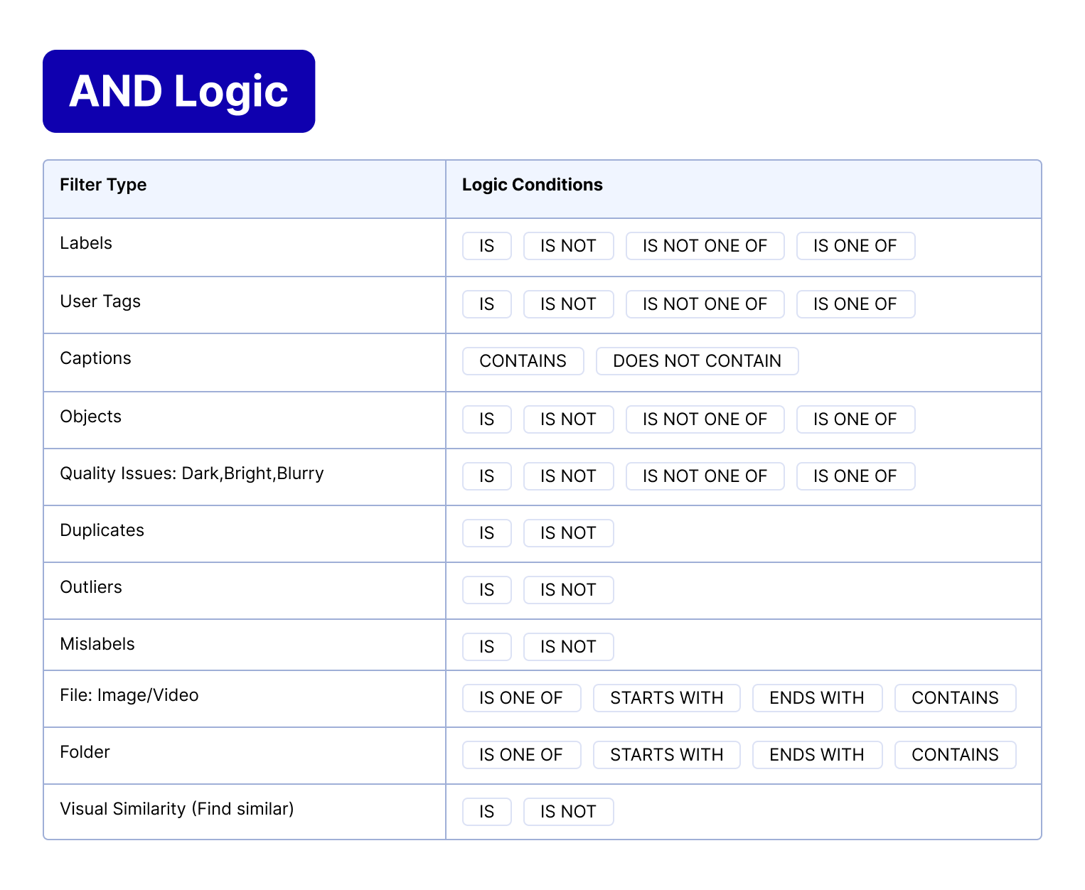

OR requirements
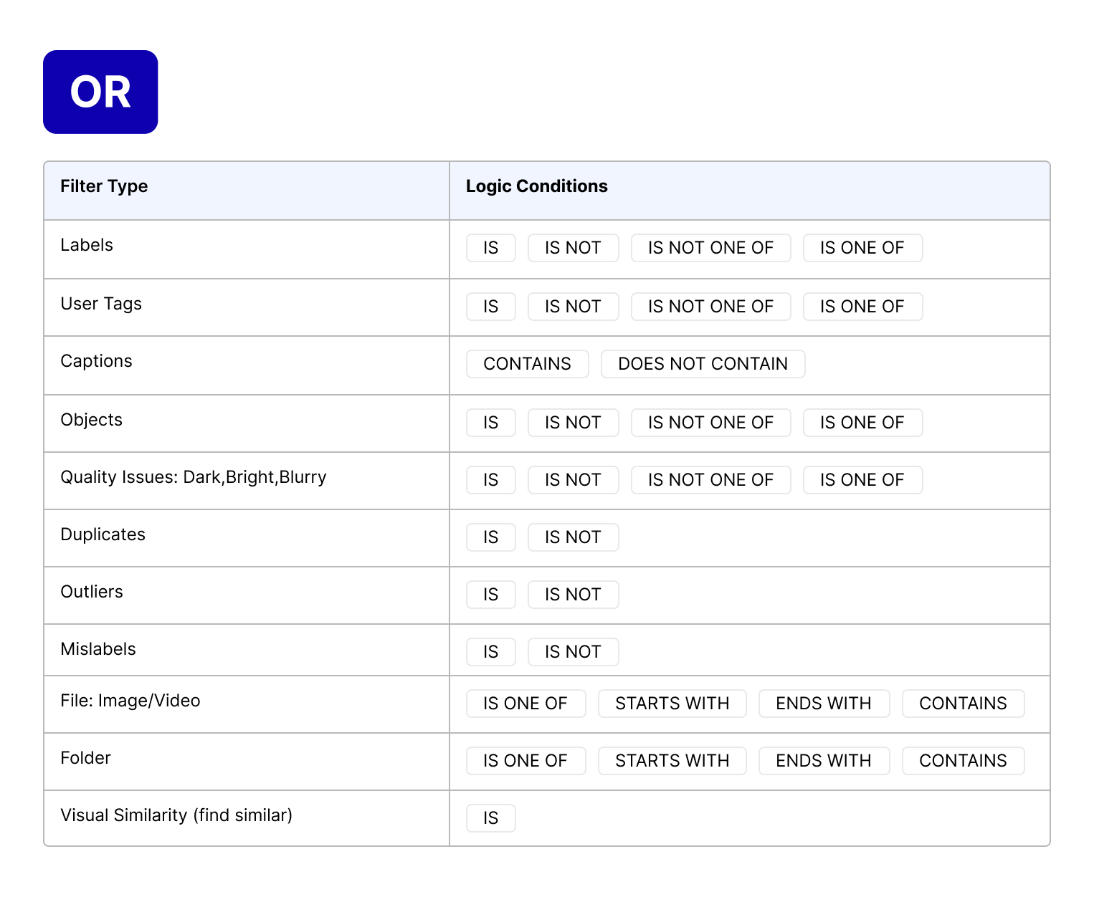

1-2 months

EXCLUDE requirements
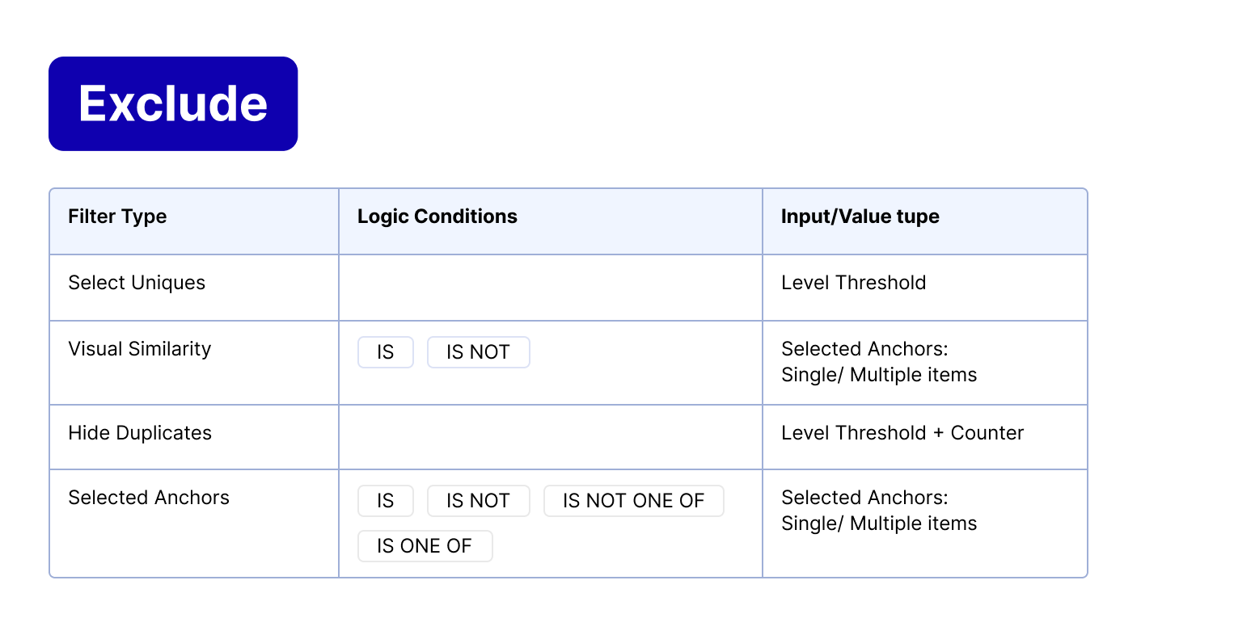

1-2 sprints

Visual Similarity requirements

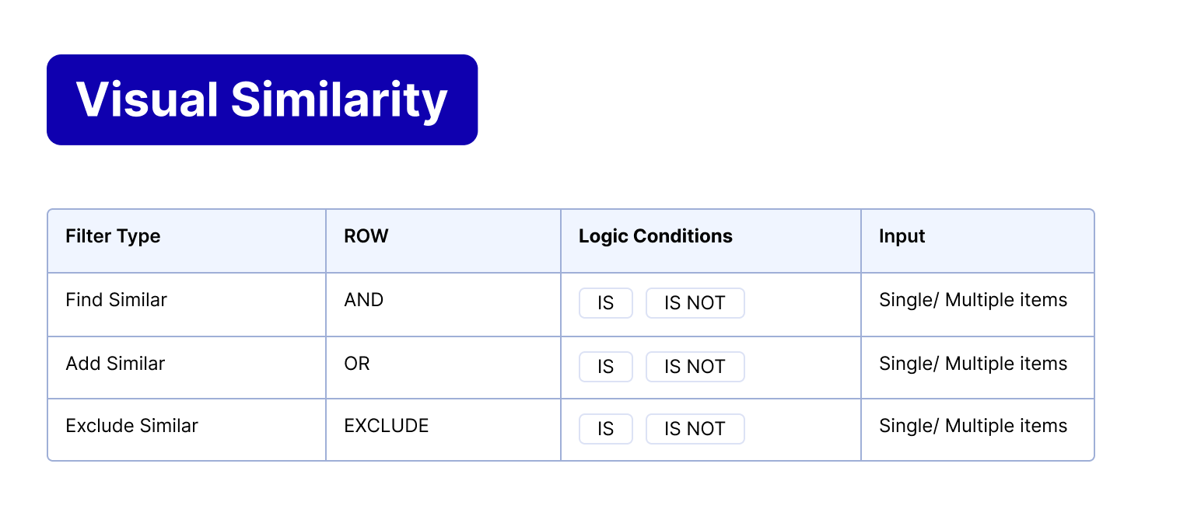
‘Is one off’ suggestion - 1 sprint

